A

Project Report on

**Portfolio**

**Hosting a Static File Portfolio on IBM Cloud**

**(Elective Module)**

Submitted in partial fulfillment of completion of the course

Advanced Diploma in IT, Networking and Cloud Computing

Submitted by:

**Archana Kumari**

Under Guidance of:

**Arpita Roy (Edunet)**

|  |  |  |
| --- | --- | --- |
| IBM-Logo - Chicago Innovation | DGT introduces high end diploma courses - digitalLEARNING Magazine | Edunet Foundation-Delhi- CSR Organization profile |

Year 2023

**PROJECT OVERVIEW**

Abstract

Acknowledgement

Table of Contents

1. Introduction to Problem
2. Proposed Solution
3. Requirements

4.1 Technology Stack

4.2 Hardware

4.3 Software

4.4 Deployment Environment

5. User Requirements

6. Design Documentation

7. Implementation Details

8. Testing

9. Deployment

10. Future Scope

11. Conclusion

Appendix A Screenshot of Project

References

**ABSTRACT**

If you're looking for information or assistance related to hosting a static file portfolio on IBM Cloud, I can certainly help guide you. A static file portfolio typically consists of HTML, CSS, and possibly JavaScript files that showcase your work or projects.

To host a static file portfolio on IBM Cloud, you can follow these general steps:

Create a Cloud Object Storage (COS) Instance:

In the COS dashboard, find the bucket containing your static files.

Enable static website hosting for that bucket and configure the main page and error page.

Access Your Static Website:

After setting up static website hosting, you'll be provided with a URL to access your static files.

Remember, these are general steps, and the exact process may vary depending on updates or changes to IBM Cloud services. It's advisable to refer to the latest IBM Cloud documentation for specific and up-to-date instructions.

If you have any specific questions or if there's a different aspect you're referring to, please provide more details, and I'll do my best to assist you!

**ACKNOWLEDGEMENT**

We would like to express our sincere gratitude to all those who have supported and contributed to the successful completion of this project. Your assistance and encouragement have been invaluable throughout this journey.

First and foremost, we want to thank my project supervisors, Arpita Roy(Edunet) and Sayanti Manna(Edunet), for their guidance, expertise, and unwavering support. Their insights and feedback have been instrumental in shaping the direction of this project.

We would also like to extend my appreciation to my fellow classmates who provided valuable input, shared resources, and engaged in stimulating discussions that enriched the project. Your collaborative spirit was a driving force behind our achievements.

Furthermore, we want to acknowledge our friends and family for their patience, understanding, and encouragement throughout this endeavour. Your support provided the motivation we needed to see this project through to its completion.

Last but not least, we are grateful to the entire faculty and staff of NSTI Kolkata for providing a conducive learning environment and the necessary resources to undertake this project.

This project has been a rewarding learning experience, and we are thankful for the collective efforts of everyone involved. Your support has been instrumental in making this project a reality.

Thank you all for being a part of this journey.

Archana Kumari,

NSTI KOLKATA

12/01/2024

**Introduction to the Problem:**

**Hosting a Static File Portfolio on IBM Cloud**

Creating and hosting a static file portfolio on IBM Cloud involves several steps. Here are common issues or challenges you might encounter:

Cloud Object Storage Setup:

Problem: Difficulty in setting up a Cloud Object Storage (COS) instance.

Solution: Ensure you follow IBM Cloud documentation to create a COS instance. Double-check your settings, including bucket configuration.

File Upload and Structure:

Problem: Issues with uploading static files or organizing them correctly in the COS bucket.

Solution: Verify that all necessary files (HTML, CSS, images) are uploaded. Confirm the correct structure and file paths.

Static Website Hosting Configuration:

Problem: Difficulty configuring COS for static website hosting.

Solution: Review the IBM Cloud documentation on setting up static website hosting. Confirm the correct configuration for the main page and error page.

Access and URL Issues:

Problem: Unable to access the hosted static website or facing URL-related problems.

Solution: Check the provided URL after setting up static hosting. Ensure your files are publicly accessible and permissions are set correctly.

Documentation Reference:

Problem: Confusion or lack of clarity in the IBM Cloud documentation.

Solution: Reread the relevant documentation sections. Look for community forums or support resources for additional guidance.

If you provide more specific details about the issue you are facing, I can offer more targeted assistance. Additionally, make sure to check the latest IBM Cloud documentation for any updates or changes in the hosting process.

**Cost-Effective Hosting:**

: IBM Cloud offers competitive pricing, and hosting a static file portfolio is generally more cost-effective than dynamic websites. You pay for the storage and bandwidth you use, making it suitable for personal portfolios or small projects.

Scalability and Performance:

IBM Cloud provides a scalable infrastructure. Your static files are distributed globally through Content Delivery Networks (CDNs), ensuring fast loading times for users around the world. This scalability ensures a seamless experience even as your portfolio grows.

Reliability and Uptime:

:IBM Cloud is known for its reliability and high uptime. Hosting your portfolio on IBM Cloud ensures that your work is accessible to potential employers, clients, or visitors consistently without downtime issues.

Security Features:

IBM Cloud incorporates robust security measures, safeguarding your static files from potential threats. With features like encryption in transit and at rest, your portfolio data remains secure.

Ease of Maintenance:

Static files require minimal maintenance compared to dynamic websites. Once uploaded to IBM Cloud, your portfolio can be easily updated by replacing or adding files without complex server-side configurations.

Developer-Friendly Environment:

IBM Cloud provides tools and services that developers find user-friendly. Integrating services like Cloud Object Storage for file storage and hosting simplifies the development and deployment process.

**REQUIREMENTS**

**TECHNOLOGY STACK**

* Frontend static website.
* Programming Languages: , HTML, CSS, and JavaScript

**HARDWARE**

* Server: A dedicated server or cloud-based virtual machine (VM) to host the Django application.
* CPU and RAM
* Storage: Adequate storage space for the database, application code, and uploaded files.
* Network Infrastructure: Reliable internet connectivity, firewalls, and security measures to protect the system.

**SOFTWARE**

* Operating System
* .html css javascripts
* Development Tools: Visual Studio Code
* IBM CLOUD
* OBJECT storage
* Version Control Tools: GitHub or GitLab
* Web Server

**DEPLOYMENT ENVIRONMENT**

* The size and complexity of the project
* The security requirements of the project
* The budget for the project
* The technical expertise of the team

**USER REQUIREMENTS**

* Mobile Accessibility or PCs
* Internet Access
* Supported Browser
* Agreement to Terms

**DESIGN DOCUMENTATION**



**IMPLEMENTATION DETAILS**

1. Implementing an portfolio project in html css involves a series of steps and tasks to create, develop, and deploy the system. Below are the implementation details and steps involved in building such a project:
2. Create a portfolio project. This can be done by running the following chrome

1. User Authentication:

**TESTING**

**This is my overall how to create project image**

 <!DOCTYPE html>

<html lang="en">

    <head>

        <meta charset="UTF-8">

        <meta name="viewport" content="width=device-width, initial-scale=1.0">

        <link rel="stylesheet" href="styles.css">

        <!-- =====BOX ICONS===== -->

        <link href='https://cdn.jsdelivr.net/npm/boxicons@2.0.5/css/boxicons.min.css' rel='stylesheet'>

        <title>Portfolio website complete</title>

    </head>

    <body>

        <!--===== HEADER =====-->

        <header class="l-header">

            <nav class="nav bd-grid">

                <div>

                    <a href="#" class="nav__logo">Archana Kumari</a>

                </div>

                <div class="nav__menu" id="nav-menu">

                    <ul class="nav__list">

                        <li class="nav__item"><a href="#home" class="nav__link active">Home</a></li>

                        <li class="nav__item"><a href="#about" class="nav__link">About</a></li>

                        <li class="nav__item"><a href="#skills" class="nav__link">Skills</a></li>

                        <li class="nav__item"><a href="#work" class="nav__link">Work</a></li>

                        <li class="nav__item"><a href="#contact" class="nav__link">Contact</a></li>

                    </ul>

                </div>

                <div class="nav__toggle" id="nav-toggle">

                    <i class='bx bx-menu'></i>

                </div>

            </nav>

        </header>

        <main class="l-main">

            <!--===== HOME =====-->

            <section class="home bd-grid" id="home">

                <div class="home__data">

                    <h1 class="home__title">Hi,<br>I'am <span class="home__title-color">Archana Kumari</span><br> Web Designer, and<br> also Web Developer</h1>

                    <a href="#" class="button">Contact</a>

                </div>

                <div class="home__social">

                    <a href="" class="home__social-icon"><i class='bx bxl-linkedin'></i></a>

                    <a href="" class="home__social-icon"><i class='bx bxl-behance' ></i></a>

                    <a href="" class="home__social-icon"><i class='bx bxl-github' ></i></a>

                </div>

                <div class="home__img">

                    <svg class="home__blob" viewBox="0 0 479 467" xmlns="http://www.w3.org/2000/svg" xmlns:xlink="http://www.w3.org/1999/xlink">

                        <mask id="mask0" mask-type="alpha">

                            <path d="M9.19024 145.964C34.0253 76.5814 114.865 54.7299 184.111 29.4823C245.804 6.98884 311.86 -14.9503 370.735 14.143C431.207 44.026 467.948 107.508 477.191 174.311C485.897 237.229 454.931 294.377 416.506 344.954C373.74 401.245 326.068 462.801 255.442 466.189C179.416 469.835 111.552 422.137 65.1576 361.805C17.4835 299.81 -17.1617 219.583 9.19024 145.964Z"/>

                        </mask>

                        <g mask="url(#mask0)">

                            <path d="M9.19024 145.964C34.0253 76.5814 114.865 54.7299 184.111 29.4823C245.804 6.98884 311.86 -14.9503 370.735 14.143C431.207 44.026 467.948 107.508 477.191 174.311C485.897 237.229 454.931 294.377 416.506 344.954C373.74 401.245 326.068 462.801 255.442 466.189C179.416 469.835 111.552 422.137 65.1576 361.805C17.4835 299.81 -17.1617 219.583 9.19024 145.964Z"/>

                            <image class="home__blob-img" x="50" y="60" href="archana.jpeg "/>

                        </g>

                    </svg>

                </div>

            </section>

            <!--===== ABOUT =====-->

            <section class="about section " id="about">

                <h2 class="section-title">About</h2>

                <div class="about__container bd-grid">

                    <div class="about__img">

                        <img src="archana.jpeg" alt="">

                    </div>

                    <div>

                        <h2 class="about__subtitle">I'am Archana Kumari</h2>

                        <p class="about__text">Hye, I am Archana Kumari i am a Web Developer and <br>Web Designer. Now i Learn New skills just like Html, Css, JS, <br> Python, laravel, BOOTSTRAP5, MONGODB, MACHINE LEARNING<br>,AWS, IBM Cloud, Now i am doing bussines Data Analytics </p>

                    </div>

                </div>

            </section>

            <!--===== SKILLS =====-->

            <section class="skills section" id="skills">

                <h2 class="section-title">Skills</h2>

                <div class="skills__container bd-grid">

                    <div>

                        <h2 class="skills__subtitle">Profesional Skills</h2>

                        <p class="skills__text">There is my Some skills What i am doing , Show my profermenses</p>

                        <div class="skills__data">

                            <div class="skills__names">

                                <i class='bx bxl-html5 skills__icon'></i>

                                <span class="skills__name">HTML5 CSS JAVASCRIPT BOOTSTRAP5</span>

                            </div>

                            <div class="skills__bar skills__html">

                            </div>

                            <div>

                                <span class="skills__percentage">95%</span>

                            </div>

                        </div>

                        <div class="skills__data">

                            <div class="skills__names">

                                <i class='bx bxl-css3 skills__icon'></i>

                                <span class="skills__name">LARAVEL PHP MYSQL MONGODB</span>

                            </div>

                            <div class="skills__bar skills__css">

                            </div>

                            <div>

                                <span class="skills__percentage">85%</span>

                            </div>

                        </div>

                        <div class="skills__data">

                            <div class="skills__names">

                                <i class='bx bxl-javascript skills__icon' ></i>

                                <span class="skills__name">DJANGO FLAX MACHINE LEARNING</span>

                            </div>

                            <div class="skills__bar skills__js">

                            </div>

                            <div>

                                <span class="skills__percentage">65%</span>

                            </div>

                        </div>

                        <div class="skills__data">

                            <div class="skills__names">

                                <i class='bx bxs-paint skills__icon'></i>

                                <span class="skills__name">UX/UI AWS IBM CLOUD</span>

                            </div>

                            <div class="skills__bar skills__ux">

                            </div>

                            <div>

                                <span class="skills__percentage">85%</span>

                            </div>

                        </div>

                    </div>

                    <div>

                        <img src="work3.jpg" alt="" class="skills__img">

                    </div>

                </div>

            </section>

            <!--===== WORK =====-->

            <section class="work section" id="work">

                <h2 class="section-title">Work</h2>

                <div class="work__container bd-grid">

                    <a href="" class="work__img">

                        <img src="work1.jpg" alt="">

                    </a>

                    <a href="" class="work__img">

                        <img src="work2.jpg" alt="">

                    </a>

                    <a href="" class="work__img">

                        <img src="work3.jpg" alt="">

                    </a>

                    <a href="" class="work__img">

                        <img src="work4.jpg" alt="">

                    </a>

                    <a href="" class="work__img">

                        <img src="work5.jpg" alt="">

                    </a>

                    <a href="" class="work__img">

                        <img src="work6.jpg" alt="">

                    </a>

                </div>

            </section>

            <!--===== CONTACT =====-->

            <section class="contact section" id="contact">

                <h2 class="section-title">Contact</h2>

                <div class="contact__container bd-grid">

                    <form action="" class="contact__form">

                        <input type="text" placeholder="Name" class="contact__input">

                        <input type="mail" placeholder="Email" class="contact__input">

                        <textarea name="" id="" cols="0" rows="10" class="contact__input"></textarea>

                        <input type="button" value="Enter" class="contact__button button">

                    </form>

                </div>

            </section>

        </main>

        <!--===== FOOTER =====-->

        <footer class="footer">

            <p class="footer__title">Archana</p>

            <div class="footer__social">

                <a href="#" class="footer__icon"><i class='bx bxl-facebook' ></i></a>

                <a href="#" class="footer__icon"><i class='bx bxl-instagram' ></i></a>

                <a href="#" class="footer__icon"><i class='bx bxl-twitter' ></i></a>

            </div>

            <p class="footer__copy">&#169; Archana Kumari. All rigths reserved</p>

        </footer>

        <!--===== SCROLL REVEAL =====-->

        <script src="https://unpkg.com/scrollreveal"></script>

        <!--===== MAIN JS =====-->

        <script src="assets/js/main.js"></script>

    </body>

</html>

**Here, index output**



**And This my About us page**

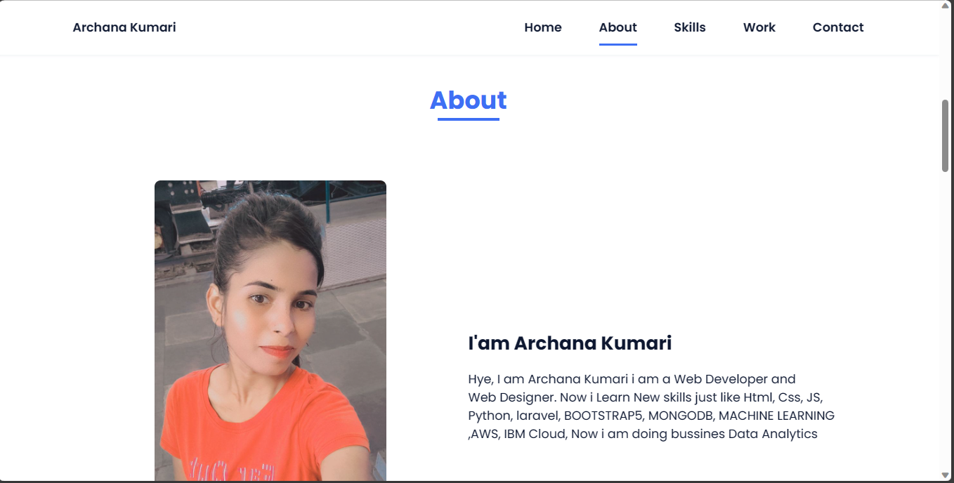

**This is student details output**

**DEPLOYMENT**

Image3: Home page of employee management system

**FUTURE SCOPE**

Here are some of the potential future features that could be added to an portfolio project in html css JavaScript

* Integration with other systems: The system could be integrated with other systems, such as a human resources system or a payroll system. This would allow for seamless data exchange and make it easier to manage portfolio

**CONCLUSION**

if you're looking for information or assistance related to hosting a static file portfolio on IBM Cloud, I can certainly help guide you. A static file portfolio typically consists of HTML, CSS, and possibly JavaScript files that showcase your work or projects.

To host a static file portfolio on IBM Cloud, you can follow these general steps:

Create a Cloud Object Storage (COS) Instance:

Log in to your IBM Cloud account.

Navigate to the IBM Cloud dashboard.

Create a new Cloud Object Storage instance.

Upload Your Static Files:

Once your COS instance is set up, upload your static files (HTML, CSS, images, etc.) to a bucket in COS. This is where your files will be stored.

Configure COS Bucket for Static Website Hosting:

In the COS dashboard, find the bucket containing your static files.

Enable static website hosting for that bucket and configure the main page and error page.

Access Your Static Website:

After setting up static website hosting, you'll be provided with a URL to access your static files.

Remember, these are general steps, and the exact process may vary depending on updates or changes to IBM Cloud services. It's advisable to refer to the latest IBM Cloud documentation for specific and up-to-date instructions.

If you have any specific questions or if there's a different aspect you're referring to, please provide more details, and I'll do my best to assist you!

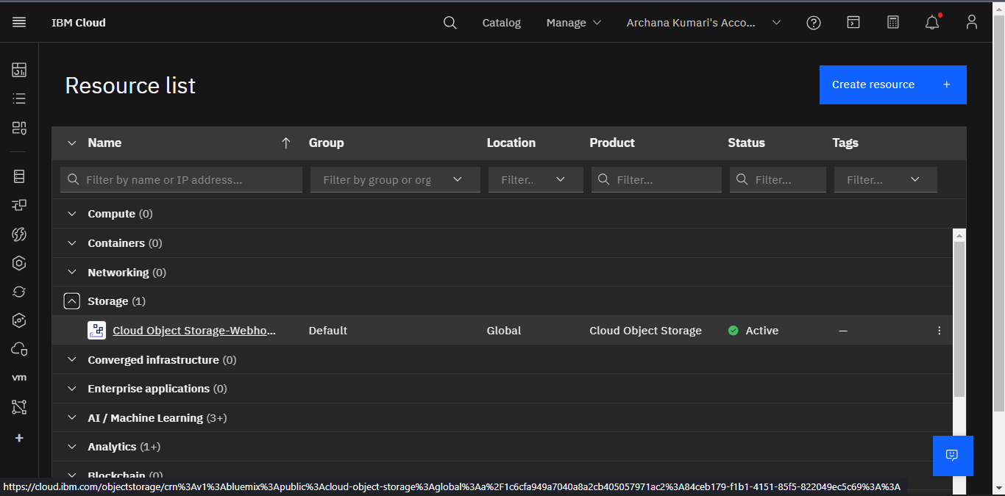

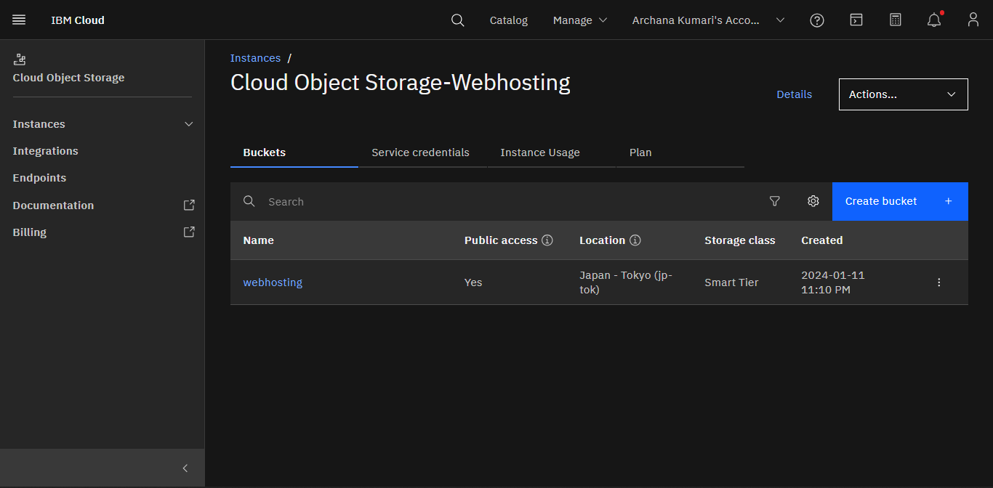

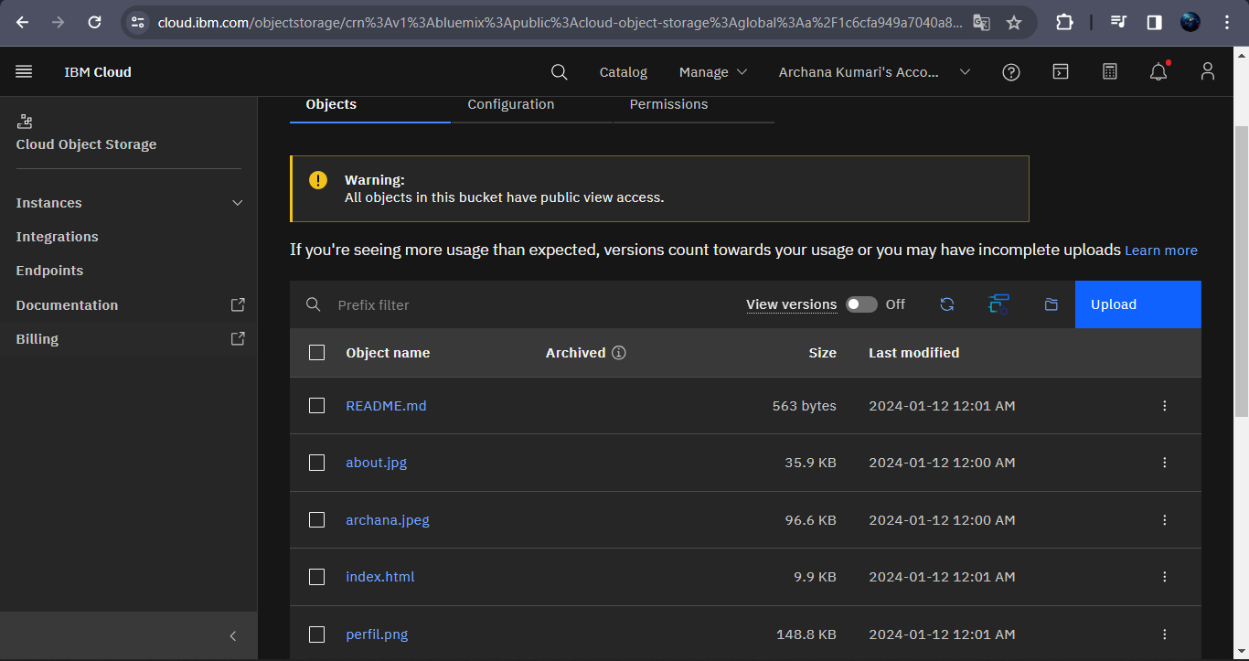

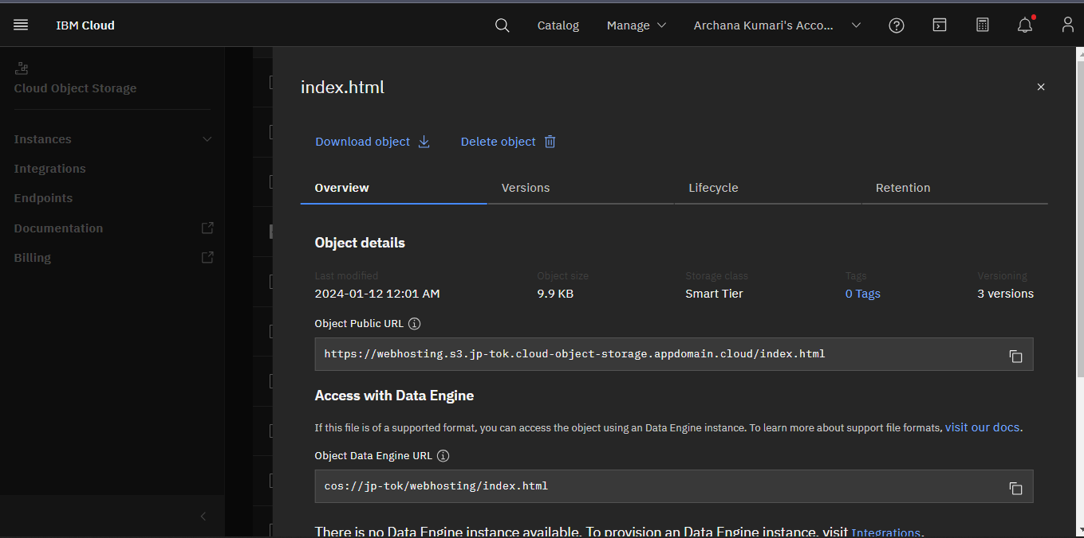

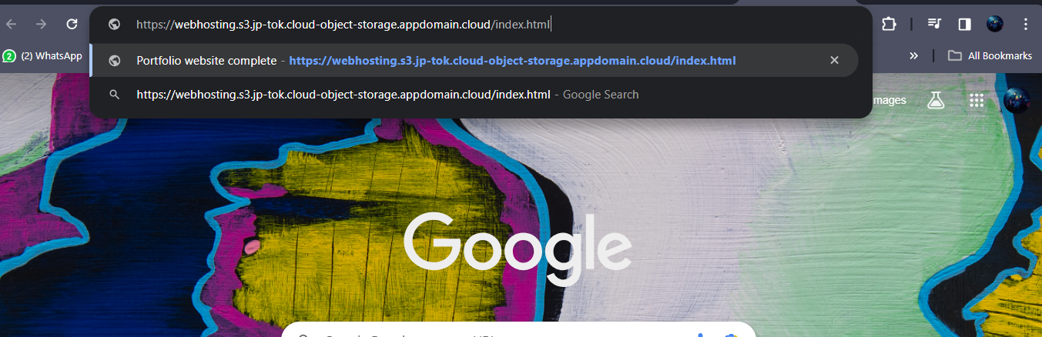

**APPENDIX A**

**SCREENSHOT OF PROJECT**

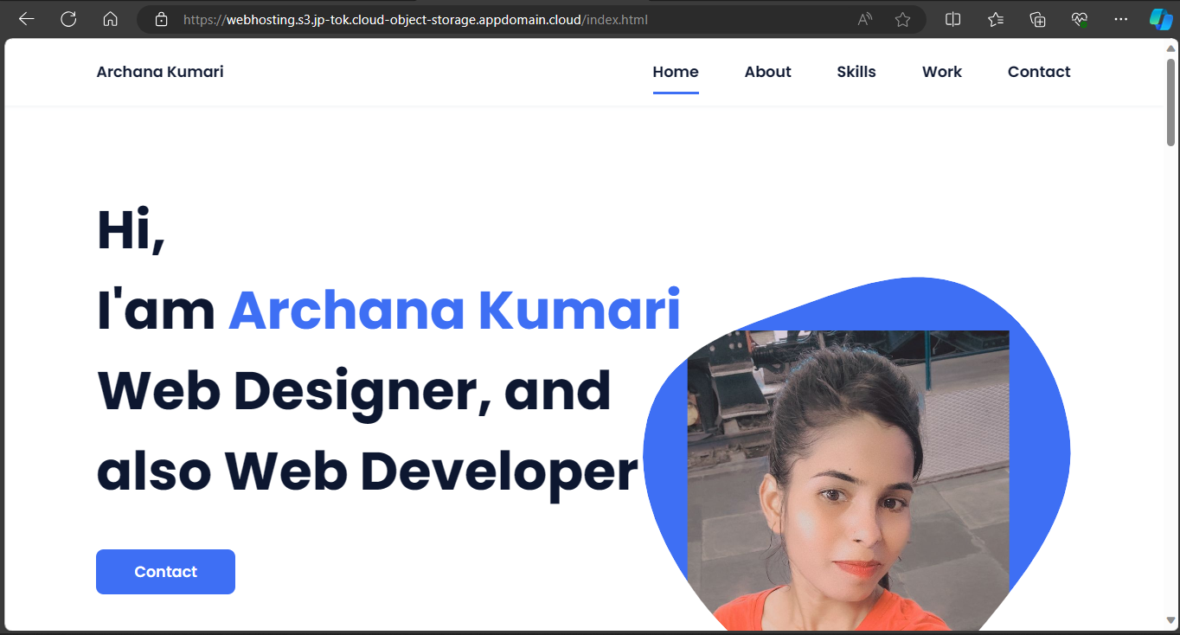

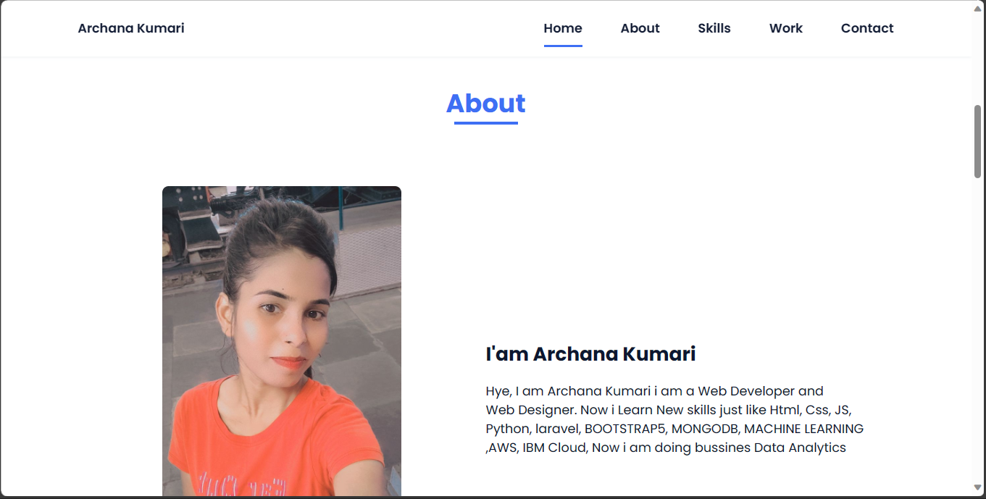

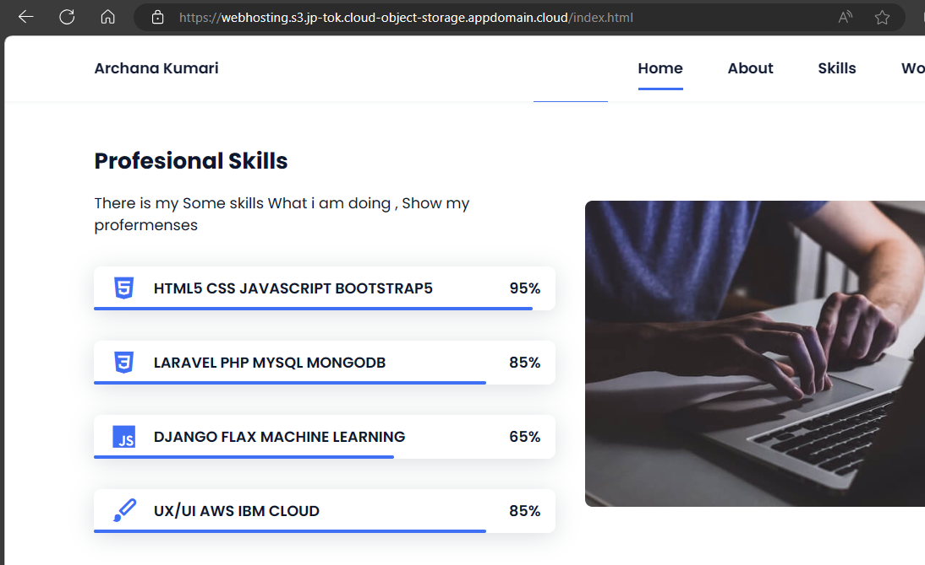



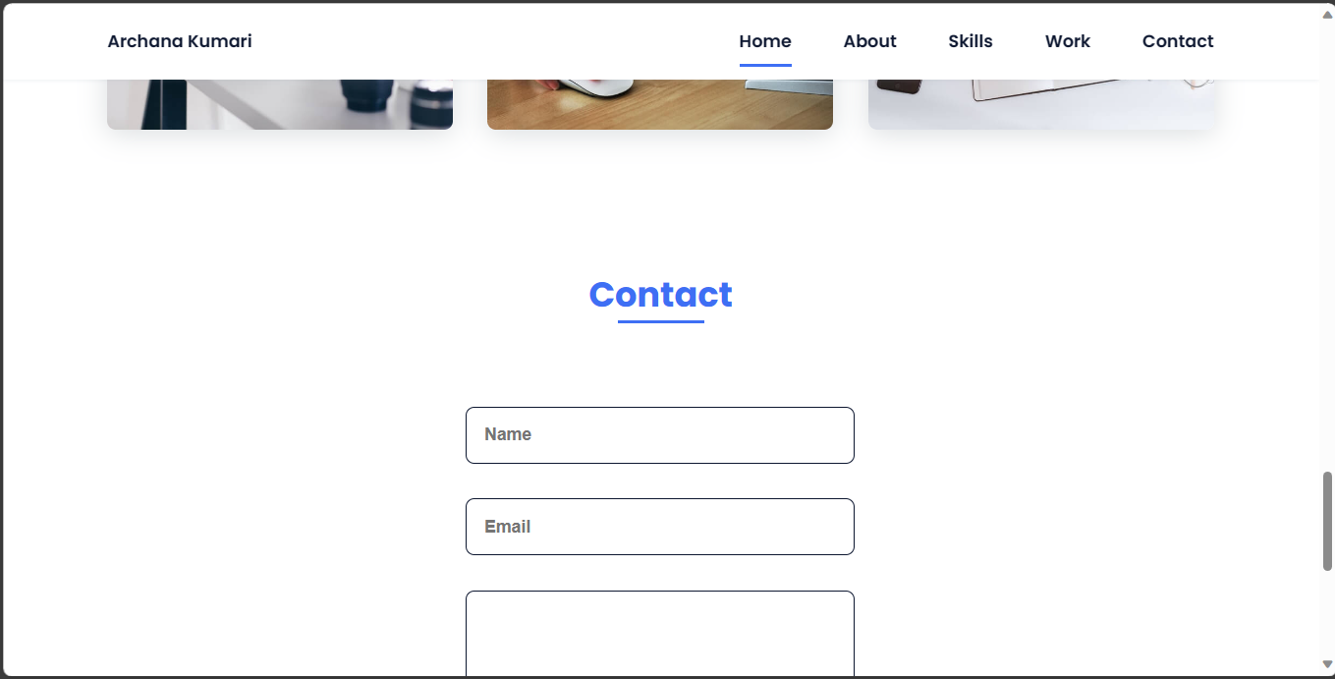

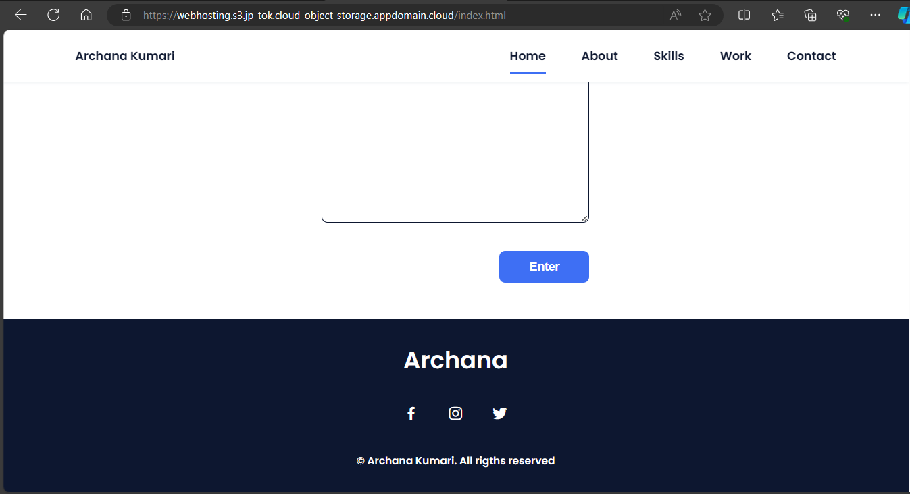

**REFERENCES**

[1] <https://webhosting.s3.jp-tok.cloud-object-storage.appdomain.cloud/index.html>

[2]